**Power Automate (Microsoft Flow)**



**Introduction**

Microsoft Power Automate is all about process automation. Power Automate allows anyone with knowledge of the business process to create repeatable flows that when triggered leap into action and perform the process for them.

* Microsoft Flow is a process and task automation tool that helps connect different applications and services together.
* [Microsoft Flow](https://flow.microsoft.com/) is a cloud-based system with which you can create automated workflows and, thus, simplify business processes and manage them more effectively.
* [**https://india.flow.microsoft.com/**](https://india.flow.microsoft.com/)
* Power Automate is all about automation.

**Common scenarios and capabilities of Power Automate:**

* Automating of repetitive tasks like moving data from one system to another.
* Guiding a user through a process so they can complete the different stages.
* Connecting to external data sources via one of the hundreds of connectors or directly via an API.
* Automating desktop based and website processes with robotic process automation (RPA) capabilities.

Purpose of this document is to articulate Best practices that can be adopted during Power Automate development.

1. Name your Flow

Whenever you create a new Flow, first thing you should do is to provide a Better name to it. Name should be simple and short to identify purpose of the flow. Few Examples are:

• Timesheet Workflow

• Travel Request Approval Process

• Task Reminder Flow

• Transfer files to SharePoint Folder

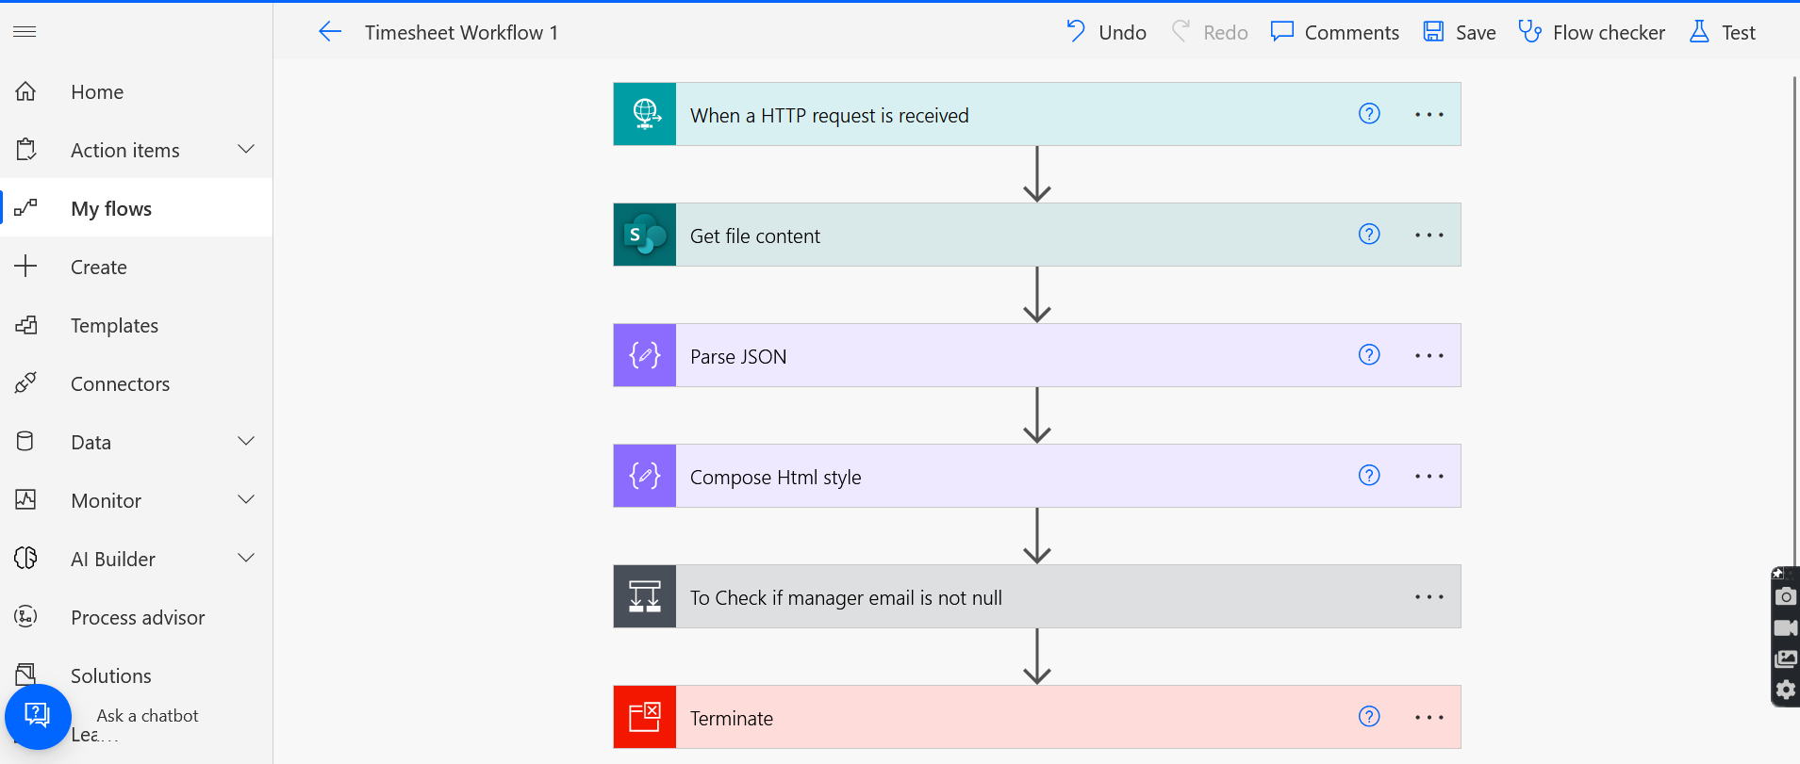

2. Edit Flow Description

Once you name the Flow, Next step is to Edit Flow Description and provide details about the flow. This will help a new person to understand the purpose of the flow.

In order to edit Flow description, Click Edit in the details section of the Flow and edit the details.

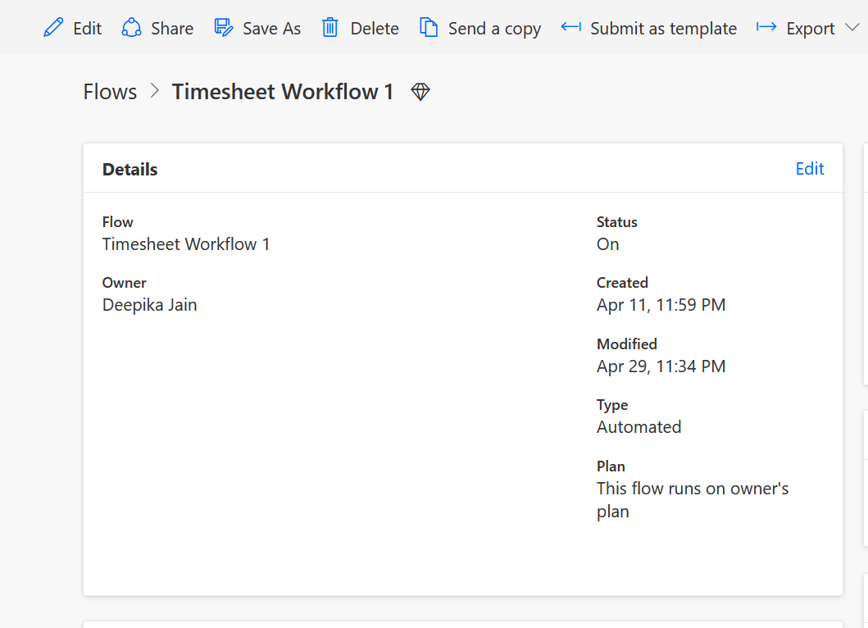

3. Consider Adding Co-Owners

If the flow you are developing is for solving any business problem, it is good practice to add a co-owner to the flow. This can be either your colleague OR Your Boss OR A Service Account in case you use it. Goal here is to keep business process running by taking over, flows developed by an employee who left the organization.

To Add Co-Owner, click Owners Section within Flow details page and click Owners. Search for the owner name and add the user.

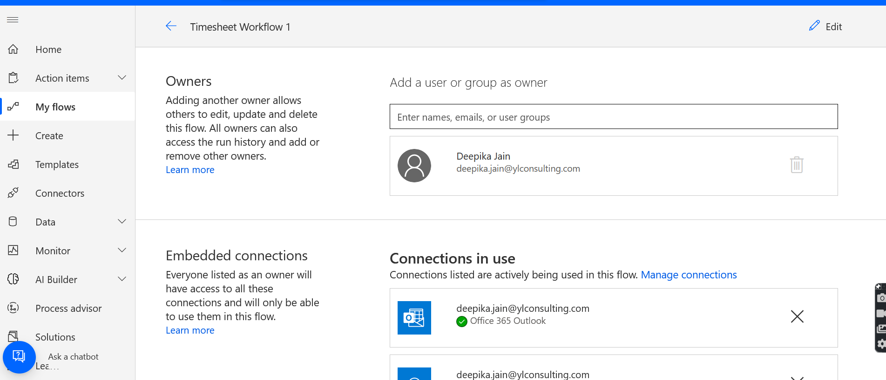

4. Create Power Automate Environments

You can create Flow Environments to control pipeline movements. It is best practice to always have at least 1 Non-Prod environment, where you can test your flow and once you find its working fine, deploy to Production Environment. Please refer following link to create Flow Environments.

<https://docs.microsoft.com/en-us/power-automate/environments-overview-maker>

5. Leverage Trigger Conditions

For Certain Trigger Conditions, you have an option to configure Trigger Conditions. It is very handy and helpful option to only trigger your flow when condition is met. This will save your flow runs in case you have restriction based on your license.

Example: I have a Flow that triggers when a new Item is saved in the List. But I want to run the flow only when Country is ‘United States’. So within trigger ‘When an item is created’, I can click Settings on Gear Icon of the Trigger and Enter following trigger condition.

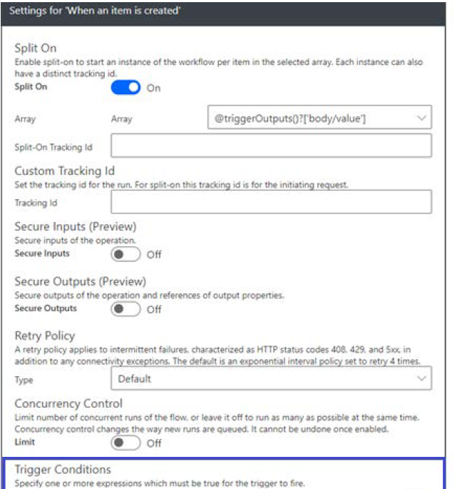

6. Name Each Action

As soon as you add any action to the flow canvas, it is recommended to name the action to something meaningful. This way, another Flow Reader would know what this action does. At the same time, if you end up having many actions in the flow and would like to search a particular field in any action, searching and identifying in the field picker becomes an easier task. Best Practice is to always name every action.

To rename an action, Click on … (ellipse) on the action Header and select rename. Following is an example of well-defined actions.

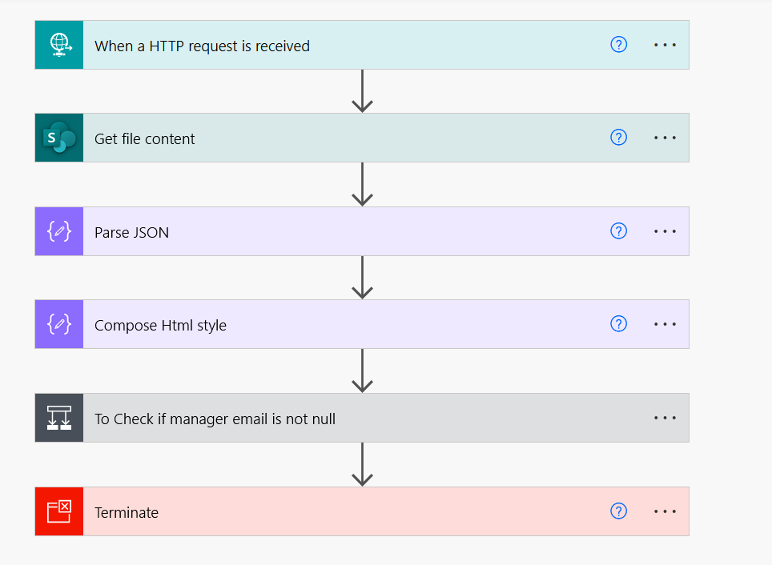

7. Consider your Flow Connections

Many a times you end up having different or many connections within Flow. If you intend to use

Service accounts, make sure that you have correct connections being used within actions. Best way is to check Flow Summary page and Click connections. Then minimize the connections if there are duplicate connections. Also you can remove unused connections listed under other connections. As we can see below, I have 1 used and 2 unused connections.

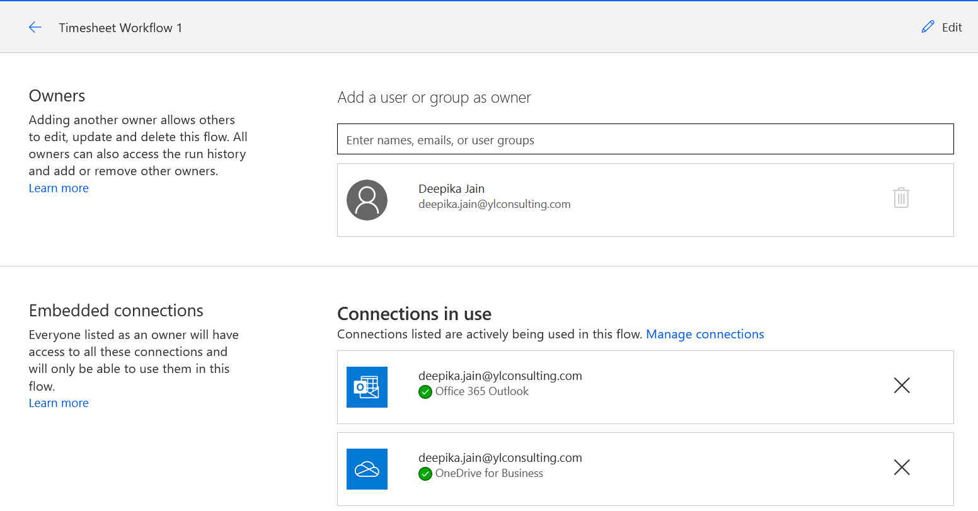



**What you can do with power automate:**

* Automate business processes
* Send automatic reminders for past due tasks
* Move business data between systems on a schedule
* Connect to more than 500 data sources or any publicly available API
* You can even automate tasks on your local computer like computing data in Excel.

**Basic Building Block of flow-**

1. **Trigger:** trigger is something which initiates or starts the flow.
2. **Action:** doing or performing something a sequence of steps on a trigger.
3. **Connector:** this will link the trigger and the element which is involved in the action.

**Note: These 3 elements will make up the flow**

**Create your first flow:**

1. Select a template that's useful for you. A simple template is [Notify and Email when a new file is uploaded to OneDrive](https://flow.microsoft.com/galleries/public/templates/ef6bf28037ca11e7870df906aa521b7a/notify-and-email-when-a-new-file-is-uploaded-to-onedrive/).

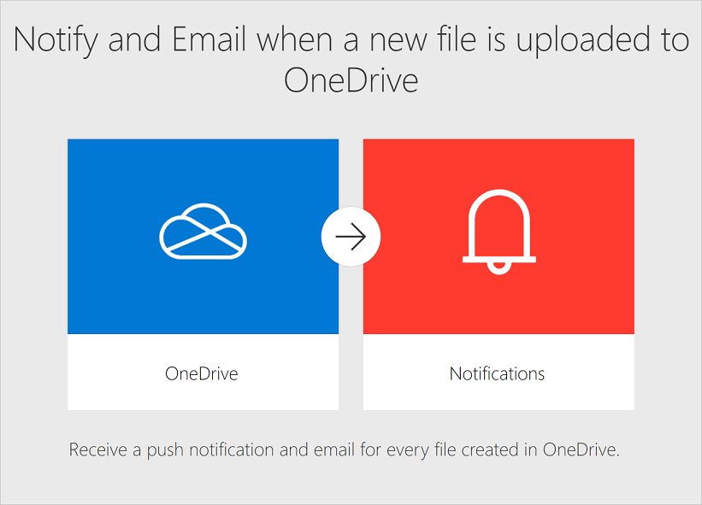

1. Select Continue.

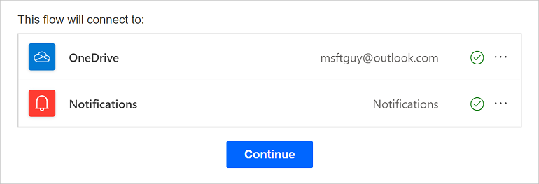

1. Select the OneDrive folder that you want to monitor.

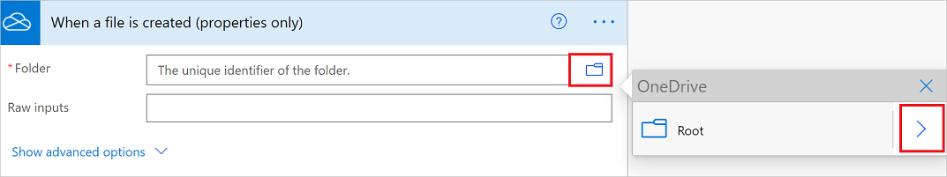

1. Select Save.

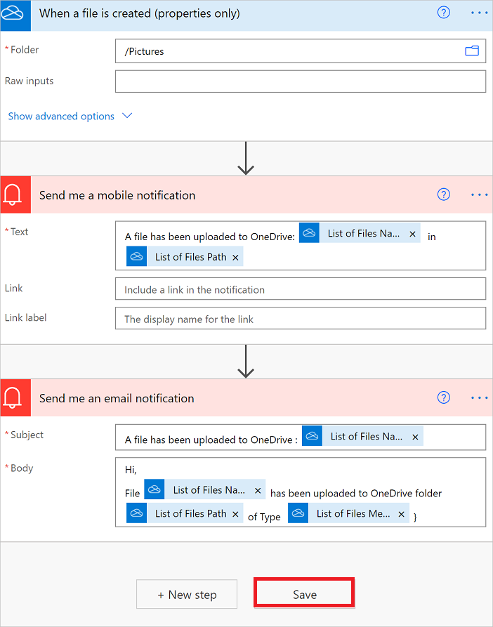

## Peek at the code

Power Automate does provide a **Peek code** feature that allows anyone to take a closer look at the code that's generated for all actions and triggers in a cloud flow. Peeking at the code could give you a clearer understanding of the data that's being used by triggers and actions.

**Types of Flows**

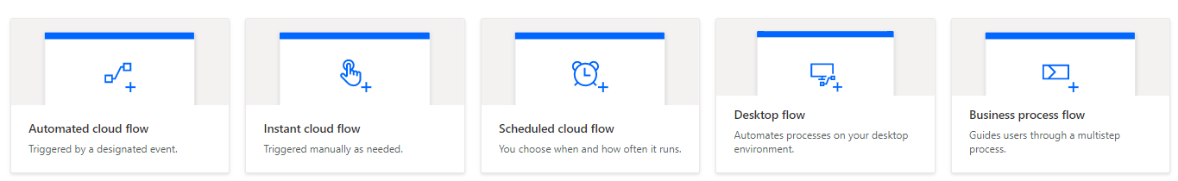

Power Automate is a service that you can use to automate repetitive tasks to bring efficiencies to any organizations.

You can create [cloud flows](https://docs.microsoft.com/en-us/power-automate/flow-types#cloud-flows), [desktop flows](https://docs.microsoft.com/en-us/power-automate/flow-types#desktop-flows), or [business process flows](https://docs.microsoft.com/en-us/power-automate/flow-types#business-process-flows).

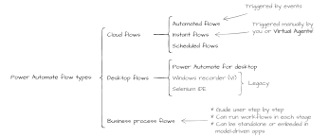

**1. Automate Flow-**

* Create an automation that is triggered by an event such as arrival of an email from a specific person, or a mention of your company in social media.

**2. Instant Flow-**

* Start an automation with a click of a button. You can automate for repetitive tasks from your Desktop or Mobile devices.
* For example, instantly send a reminder to the team with a push of a button from your mobile device.

**3. Schedule Flow-**

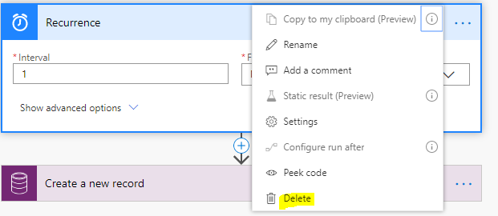

Schedule an automation such as daily data upload to SharePoint or a database.

**4. Desktop Flow-**

* Desktop flows are used to automate tasks on the Web or the desktop.
* Using [Power Automate Desktop](https://docs.microsoft.com/en-us/power-automate/desktop-flows/introduction) you can automate tasks on the desktop as well as the Web.

**5. Business process flow-**

* [Business process flows](https://docs.microsoft.com/en-us/power-automate/business-process-flows-overview) provide a guide for people to get work done.
* They provide a streamlined user experience that leads people through the processes their organization has defined for interactions that need to be advanced to a conclusion of some kind.
* This user experience can be tailored so that people with different security roles can have an experience that best suits the work they do.

**Types of Flows**

**Cloud**

**Flows**

Instant Flow

**Desktop Flows**

Automated Flow

Schedule Flow

**Business Flows**

**Examples of flows**

* **Variables:** variable is a container which holds value.

Example: x= 10;

* **Datatype:** the type of value which a variable can hold.

Example: string employeeName=”Mittal Agrawal”

* **Types of datatypes:**

1. Integer -1, 120
2. String- ex xyz, march
3. Float -numeric as fractional part 11.3 , 44.7
4. Boolean –can contain either a true or false value
5. Arrays- is a list of values
6. Object – It can hold any of the above datatype

* **Steps for Creating a variable type flow-**

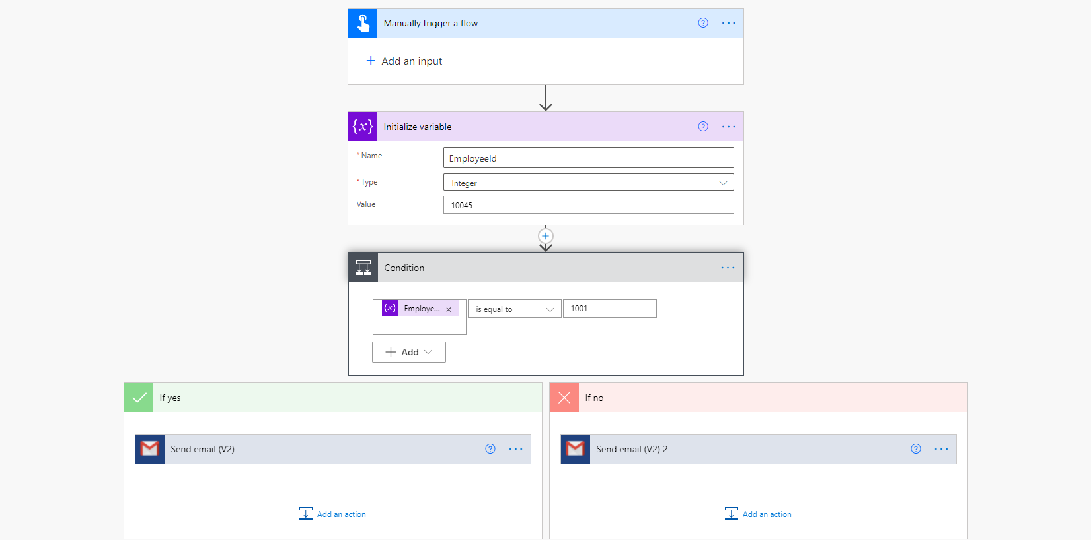

**Example1**

1. Create->>My Flow->>Automated Flow (from blank) ->>Give flow name->>”Datatype”

2. Manually trigger a flow

3. Initialize a variable

* Enter a variable name: Employee ID
* Type: Integer
* Value:1001

4. Now select new step->> select condition ->>Control

Choose a value: Employee ID

**Example2: Array data type**

3. Initialize a variable

* Enter a variable name: Employee ID
* Type: Array
* Value:[1]
* Value:[“Computer”]

**Note:**

1. **If I am using array as a datatype, then use [] square brackets**
2. **If you are putting integer don’t use quotation marks**
3. **If you are putting string value, then use quotation marks**

**Schedule Flow**

**Example:**  I need to shoot an email to fill timesheet to all employee

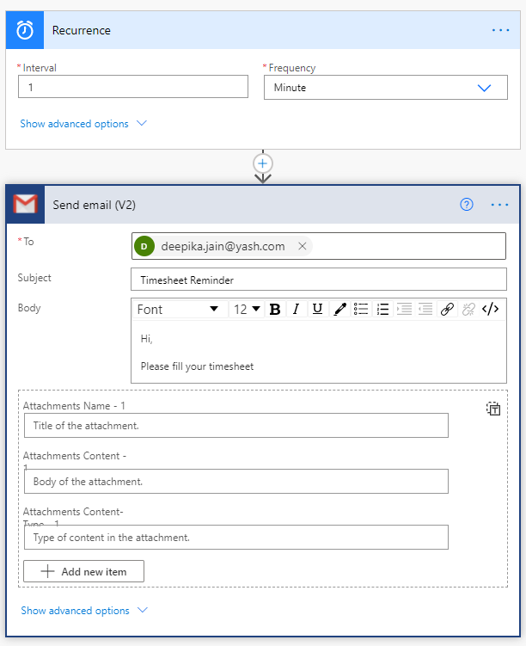

**Approval Workflow for SharePoint Item/List**

Whether you need written acknowledgment from your manager or a formal authorization from a diverse group of stakeholders, getting things approved is part of almost every organization.

With the approvals capability in Power Automate, you can automate sign-off requests and combine human decision-making for workflows. Some popular cases where approvals can be used include:

* Approving vacation time requests.
* Approving documents that need sign-off.
* Approving expense reports.

When you submit an approval in a flow, approvers are notified and can review and act on the request.

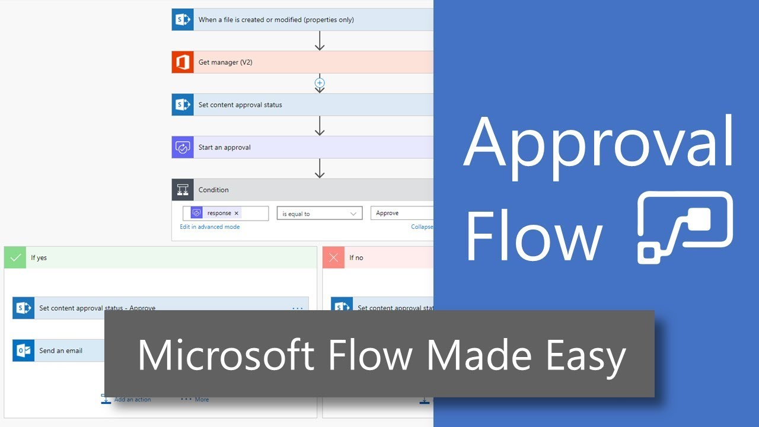

* Approval workflow is required when we need approval from the different resources.
* An approvalworkflow is a logical sequence of tasks, including human approvals, to process data. Approvalworkflows are unique in that the process will halt until the specific person approves the data.
* **Important Link**- https://docs.microsoft.com/en-us/power-automate/all-assigned-must-approve

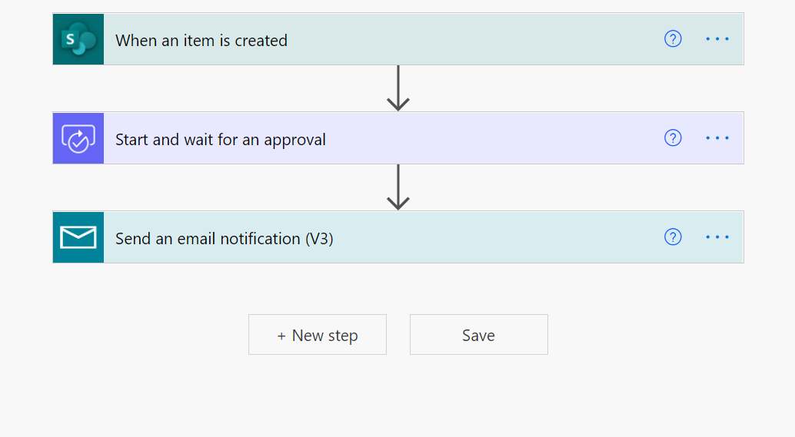

**Types of Approvals:**

1. Everyone must approve – approve or reject

* It can have multiple approvers
* Like manager, IRM, Finance Team all of them have to approve

2. Approve/Reject-First to Respond

* It also has the option to approve or reject but it will act based on the response which is received from the first responded
* For example, manager 1 respond and manger 2 does not respond then it will move with the manger 1 response.

3. Custom Responses- Wait for all responses

* We can add more options other than approve/reject like Keep on hold, notify the employee etc.
* It will wait for everyone to approve.

4. Custom Response- wait for one response

* Same as above if one approver responds from the approver list then the approval flow will go ahead

**Example:**

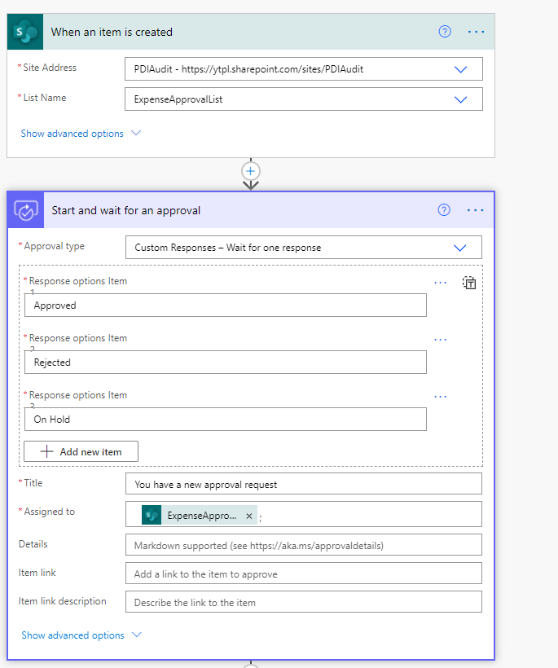

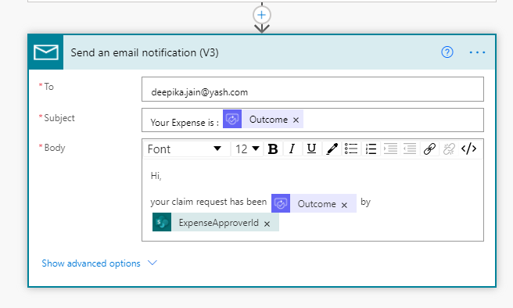

**Templates Examples**

You can choose any predefined templates->>Go to templates->>All Flows ->>Search “Save tweets to google sheet”

**Example:** Save tweets to google sheet

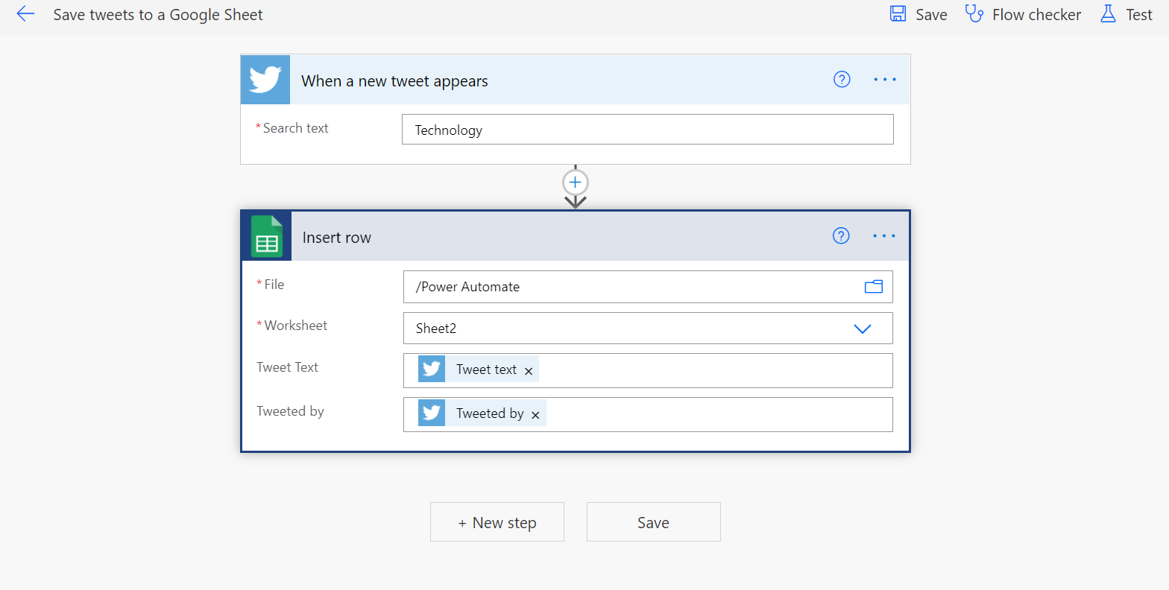

**Connectors**

* A connector is a proxy or a wrapper around an API that allows the underlying service to talk to Microsoft Power Automate, Microsoft Power Apps, and Azure Logic Apps.
* A connector may provide **tables** of data or **actions**. Some connectors provide only tables, some provide only actions, and some provide both. Also your connector may be either a standard or custom connector.
* Examples of popular connectors include **Salesforce, Office 365, Twitter, Dropbox, Google services, and more**.
* **Polling Triggers**—these triggers call your service at a specified frequency to check for new data. When new data is available, it causes a new run of your workflow instance with the data as input.
* **Push Triggers**—these triggers listen for data on an endpoint, that is, they wait for an event to occur. The occurrence of this event causes a new run of your workflow instance.
* **Custom connectors**

While [Azure Logic Apps](https://azure.microsoft.com/services/logic-apps), [Microsoft Power Automate](https://flow.microsoft.com/), and [Microsoft Power Apps](https://powerapps.microsoft.com/) offer over [325+ connectors](https://docs.microsoft.com/en-us/connectors/connector-reference/) to connect to Microsoft and non-Microsoft services, you may want to communicate with services that aren't available as prebuilt connectors.